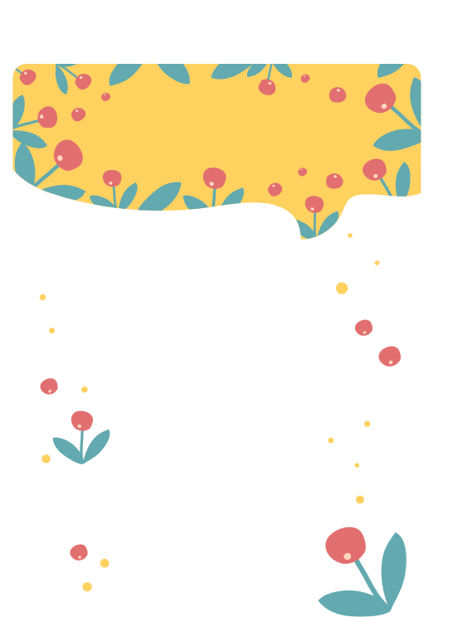

***DEAR FRIEND,***

***,***

***FRANKLIN SMITH***

***SINCERLY***

Thank you for entering my life. I strongly believe in having "a person," and there is no better person to fit that description than you. For the last two years of my life, I have been through so many different stages, like graduating, falling out with friends, a new school, and through all of the good and bad times, you have been with me. I couldn't thank you enough for that. To me, it is so important for your friends to be proud of you when you get a new job, learn something new, or just accomplish big things. But it's also really important for your friends to just be proud that you got out of bed that day, so today, January 7, I am so proud of you for waking up and just having a day!

I want you to know, I don't need a large group of friends when I have one that constantly reminds me all of the time that they are there for me in every way possible. I thought my whole life that I knew what a best friend was, but I was wrong. You've given those words a whole different meaning. Nobody could ever compare to you.