CAFE & BISTRO

**Menu**

WAFFLES

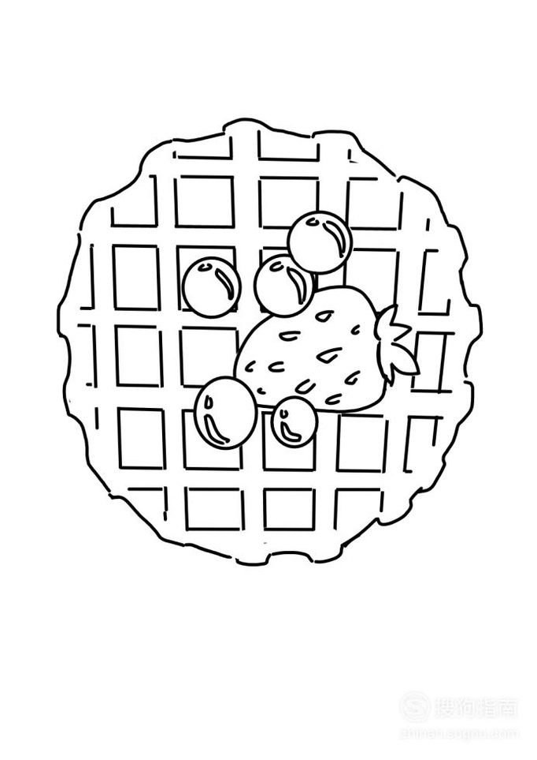

**CARAMEL WAFFLES**

MOLLIT AUTE LABORIS $8

**PANCAKES**

DOLORE UT CUPIDATAT $12

**PANCAKES**

EXRCITATION DOLORE AU $12

**CARAMEL WAFFLES**

MOLLIT AUTE LABORIS $8

COFFEE

**ESPRESSO**

12 OZ/20 OZ $6/$8

**AMERICANO**

12 OZ/20 OZ $8/$10

**CAPPUCCINO**

12 OZ/20 OZ $8/$10

**ESPRESSO**

12 OZ/20 OZ $6/$8

