The IP of the Little Yellow Duck family will generate HK$98.039 million in licensing revenue in 2020 and HK$135 million in sales revenue, totaling approximately RMB 200 million.
On May 4th, Deying International Holdings Limited (hereinafter referred to as Deying, although the more familiar name is Senke), the Hong Kong character licensing company and the behind-the-scenes company of B.Duck, once again reported to Hong Kong United The exchange has submitted an application for listing.
To say it again, it was submitted once in March 2019. Sanwen Entertainment has analyzed it before and reviewed: Little Yellow Duck’s annual income is 70 million, and Fujian shoe companies are the largest customers.
Deying's income structure
In the three years from 2018 to 2020, the revenue of Deying's role licensing business was HK$63.827 million, 81.63 million and HK$98.039 million respectively.
Deying's other business, e-commerce and others, mainly sells products of the Little Yellow Duck family on platforms such as Tmall, JD.com, Vipshop, HKTVmall, and offline channels. The revenue from 2018 to 2020 is 137 million and 161 million respectively. million and HK$135 million.
Deying's licensing income mainly comes from the IP of the Little Yellow Duck family. As of the end of 2020, Deying has created and operated a number of characters, mainly
including the role of Little Yellow Duck (B.Duck), Little Yellow Duck Sister (Buffy), Little Yellow Duck (B.Duck Baby), DongDuck created for Zhou Dongyu, and Black Duck Bath'N Duck.
In 2020, Deying's licensing income through B.Duck increased from HK$53.892 million in 2018 to HK$75.035 million; Buffy's income increased from HK$6.082 million in 2018 to HK$7.831 million, and B.Duck Baby's income increased from HK$3.351 million HK$10,000 increased to HK$13.451 million, DongDuck's licensing income was HK$136,000, and Bath'N Duck's licensing income was HK$725,000
Deying's role authorization income composition
Deying sells its own products through e-commerce and offline channels, mainly looking for OEM, that is, OEM, and the products are mainly clothing and bags. Next, Sanwen Entertainment mainly analyzes its licensing business model.
The main product categories of Deying's retail business
In the past two years, the sales revenue of Deying's Vipshop and JD.com has grown rapidly, but it is still small compared to Tmall. In 2020, Deying earned HK$101 million from the Tmall channel, HK$24.211 million from the Vipshop channel, HK$3.25 million from the Jingdong channel, and the offline channel fell to HK$5.618 million due to the impact of the epidemic.
Deying's sales channels

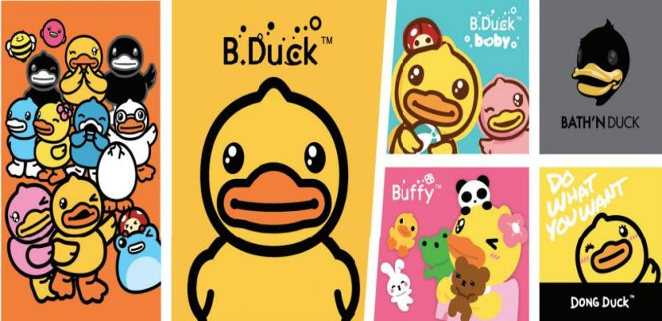
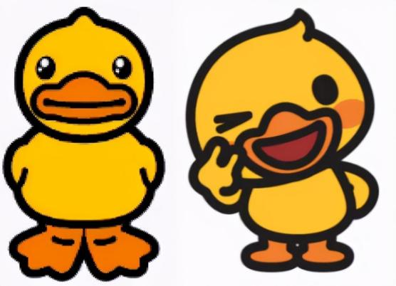
The authorized monetization model of the little yellow duck
The little yellow duck family has 25 characters, mainly including the three ducks below. Buffy and Baby, derived from the little yellow duck created in 2005, are the main segments, targeting young women and baby markets respectively.
Deying's three main images
Based on Little Yellow Duck, Deying has developed five businesses: merchandise licensing, live-action entertainment licensing, content and media licensing, promotion licensing, and design consulting.
Deying's main business is carried out in Hong Kong, mainland China and other Five licensing business models
Deying International's authorized customers cover a number of consumer sectors. The top five customers in 2020 are Lixun Group, which produces shoes and clothing, Customer A (Sanwen Entertainment Note: should be Vipshop), China Everbright Bank,
and Xiaohuangya Milk Tea. The catering company Shanghai Zhichao brand management and production and sales of tableware dark horse technology. Among the top five customers in 2018-2019 are Overseas Chinese Town, an indoor amusement park in Hong Kong, Shenzhen Qianhai Shiweixian Food Co., Ltd., etc.
- Product authorization
Commodity licensing is the main source of Deying's revenue and profit.
Deying International licenses the Little Yellow Duck family to third-party products of various consumer product categories, which are roughly divided into six categories:

1) Household and daily necessities, with more than 1200 SKUs;
2) Apparel and accessories, with more than 12,000 SKUs;
3) Toys and infant personal care, with more than 650 SKUs;
4) Shoes, with more than 3700 SKUs;
5) Consumer electronics, with more than 200 SKUs;
6) Others, including stationery, watches, drinks, etc., have more than 600 SKUs.

These commodities and household items have contributed more revenue than clothing and accessories.
Categories such as digital products have much smaller volumes.
The largest customers of Deying International are also from the clothing and accessories category. The first customers in the four years from 2017 to 2020 are all Fujian Quanzhou shoe company Lixun Group.
2. Live entertainment authorization
Deying's live-action entertainment authorization mainly includes: 1) theme parks and attractions; 2) catering; 3) promotion and marketing activities.
In 2020, the Little Yellow Duck theme park co-operated by Deying and OCT opened in Nanjing.
Deying and Nanjing Baocheng Culture and Entertainment Development Co., Ltd. have signed contracts in mainland China to cooperate on 15 indoor entertainment centers, including B.Duck theme children's playgrounds, retail stores and restaurants. Currently, two have opened in Sanya and Changsha, and others are planned to open in Nanjing, Guangzhou, Chengdu, Hangzhou and Xi'an.
As of the end of 2020, Deying has authorized the opening of 20 Cantonese dim sum restaurants featuring Buffy in Beijing, Shanghai, Suzhou, Chongqing and other places, and plans to cooperate with Shiweixian to open 16 new restaurants by 2022; Over 140 Little Yellow Duck Milk Tea Shops - what Deying calls a modern tea house featuring B.Duck (in partnership with Zhichao brand).
(Aiman, which has recently received financing again, also includes IP-themed restaurants. Reviewing the report from Sanwen Entertainment: Aiman ​​has raised tens of millions of yuan and will open 12 IP-themed restaurants this year.

3. Promotion authorization
Deying will also be used for different types of third-party promotion and marketing projects such as gifts and premiums based on IP such as Little Yellow Duck. This model is similar to the main business of Kahn Culture, another company previously reported by Sanwen Entertainment. Review: Take Disney and other authorizations as IP
promotional items, and Kahn Culture, with an annual income of 330 million yuan, will be listed by Kahn Culture. Promotional items are mainly baby carriages and small toys.
Main categories of Kahn cultural promotional items
The gift categories provided by Deying include clothing and accessories, toys, household and daily necessities and consumer electronic products for customer
promotion activities. It is also cooperating with credit card gift exchanges, welcome gifts, VIP gifts, etc.
Cases in this regard include: Watsons, Meiyijia Convenience Store, Mead Johnson Milk Powder, McDonald's, Everbright Bank Credit Card, Thailand Lotus Supermarket (the original Thai version of CP Lotus).
Since the promotion activities are generally one-off and short-term in nature, the license contract period does not exceed about 18 months, but the prospectus shows that the Little Yellow Duck IP also has good results:
For example, Watsons redeemed more than 550,000 pieces of Little Yellow Duck promotional products (including clothing and accessories and personal care products) in China during the promotion period;
Meiyijia exchanged more than 660,000 pieces of Little Yellow Duck promotional products in China during the approximately nine-month promotion period; Mead Johnson exchanged over 60,000 pieces of Little Yellow Duck Promotional products
(mainly personal care products) in China during the approximately one-year promotion period; McDonald's Little Yellow Duck-themed birthday party distributed more than 280,000 Little Yellow Duck birthday gifts (including pencils, pencil cases and game boards) in about a year; China Everbright Bank applied for the distribution of more than 1.2 million Little Yellow Duck credit cards during the promotion period; Lotus. Supermarket Thailand redeemed over 900,000 pieces of Little Yellow Duck promotional products (mainly personal care products) in Thailand under two redemption events.

4. Content and Media Licensing
Deying's content and media licensing, including offline content (such as children's books and credit cards) and digital entertainment and media (such as stickers, mobile games, etc.), as well as the little yellow duck family emoji package on chat tools such as Line and Kakao , the general authorization period is six months to no more than 5 years.

5. Design consultation
Deying has formed a team of designers and authorized, sales, and marketing personnel to provide authorized customers with a complete role and product design process, and assist customers to develop products for different markets and different channels.

