Titanic
The RMS Titanic, also translated as Titanic, is an Olympic-class cruise ship under the jurisdiction of the British White Star Shipping Company, with a displacement of 46,000 tons. It was at Harland and Wolfe Shipyard on March 31, 1909. Construction started, launched on May 31, 1911, and the sea trial was completed on April 2, 1912.
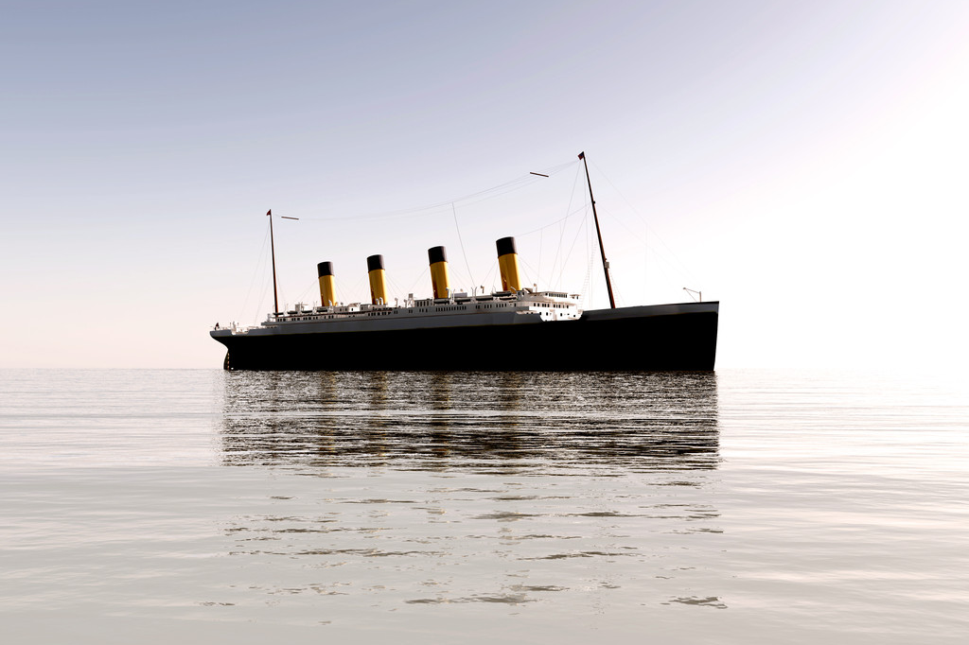
The Titanic was the world's largest passenger ship with the most luxurious internal facilities at the time, and it had the reputation of "never sinking". Unfortunately, during its maiden voyage, the Titanic suffered bad luck-it sailed from Southampton, England to New York, USA. At about 23:40 on April 14, 1912, the Titanic collided with an iceberg, causing the starboard bow to the middle of the ship to rupture, and five watertight tanks flooded. At about 2:20 am on April 15, the Titanic's hull broke into two pieces and sank 3,700 meters below the Atlantic Ocean. Of the 2,224 crew and passengers, 1,517 were killed, and only 333 of the victims were recovered. The sinking of the Titanic was the most deadly shipwreck in peacetime. Its wreck was not discovered again until 1985 and is currently protected by the United Nations Educational, Scientific and Cultural Organization.

