Vincent Willem van Gogh
Sunflowers
"Sunflowers" (French: Les Tournesols; Dutch: Zonnebloemen; English: Sunflowers) was painted by the Dutch painter Vincent Van Gogh from August 1888 to January 1889, with sunflowers inserted in bottles as the main A series of oil paintings of the content, the works respectively draw 3, 5, 12, and 15 sunflowers in a vase. They are collected in the New Museum of Art in Munich, Germany, the National Gallery in London, England, the Koya Art Museum in Tokyo, Japan, the Van Gogh Museum in Amsterdam, the Netherlands, and the Philadelphia Museum of Art in the United States.
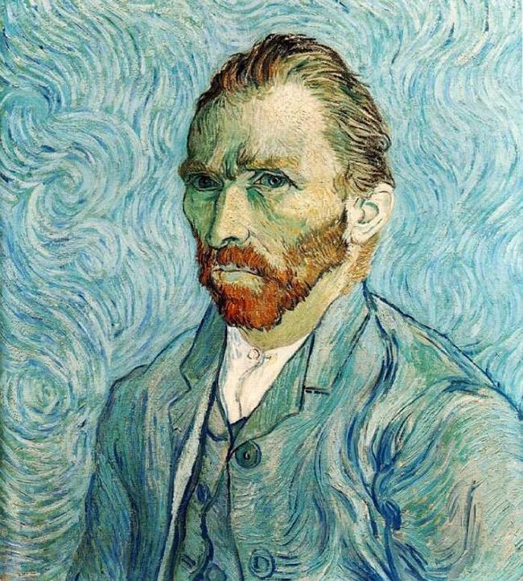

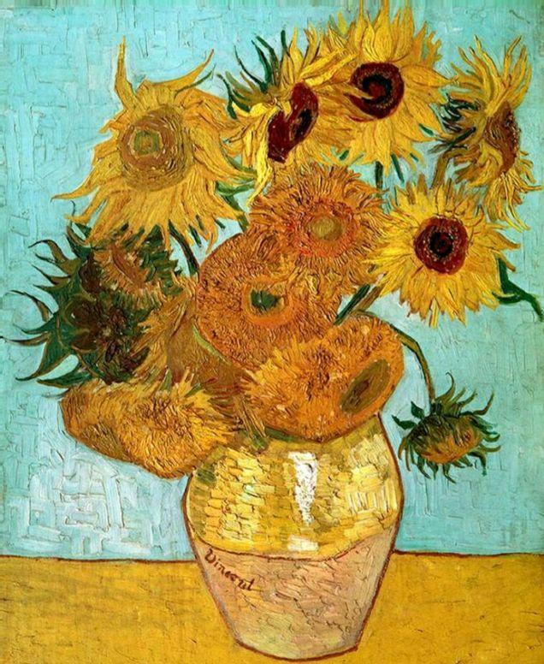
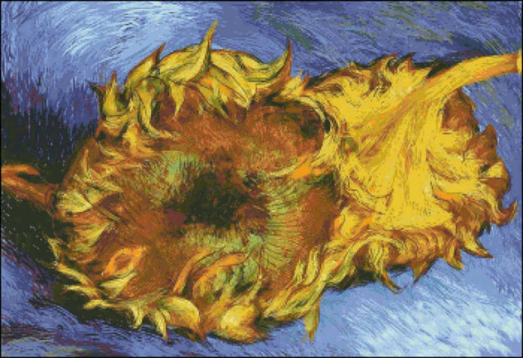
If defined by Van Gogh's "oil paintings with sunflowers in vases as the theme", then it is widely believed that there are 7 works in total. Six of them have been preserved. Of the six sunflower paintings preserved, three are painted with 15 sunflowers, two are painted with 12 sunflowers, and one is painted with 3 sunflowers. In addition, if you count the works created in Paris, there are a total of 11 (or 12), including sunflower works that are not in the flower pots.
Through this series of works, Van Gogh expressed his understanding of life to the world and showed his unique spiritual world. This series of works also conveys such a message: treat family members with gratitude, treat others with kindness, treat friends with honesty, treat work with sincerity, treat life with gratitude, Enjoy art with a heart of appreciation, just like the bright sunflowers in front of you.

"Twelve Sunflowers in a Vase" F456
The work is collected in the Neue Pinakothek, Munich, Germany. The work can be collected in Germany thanks to the courage and confidence of an art museum worker. Hugo von Tschudi bought Impressionist works for the Berlin National Gallery in 1900. At that time, German art galleries were quite dissatisfied with French modernist art, so the curator Kaiser Wilhelm dismissed him. Hugo von Tschudi is convinced of his own vision. He continued to acquire the works of many emerging French artists.

